**North South University**

**CSE 311L**

**Section:9**

**Project Report:**

Name:Fardin Bin Islam

ID:1721588642

Individual **Project Assessment:**

Topic:Online Escape Room Booking

**Introduction**

We have created an online escape booking system which is a web portal. Here, you can book reservations in advance, know your timing, watch the various themes and read reviews for the same. You can know everything about a room and its show rates and show time just from our site. As it digitalizes the ticketing process, we believe that we could use the Online Escape Room System in other booking industries too.

**Work Statement:**

Me and Safa were responsible for the project idea.I attempted once prior the final design ,as shown by the snapshots below.

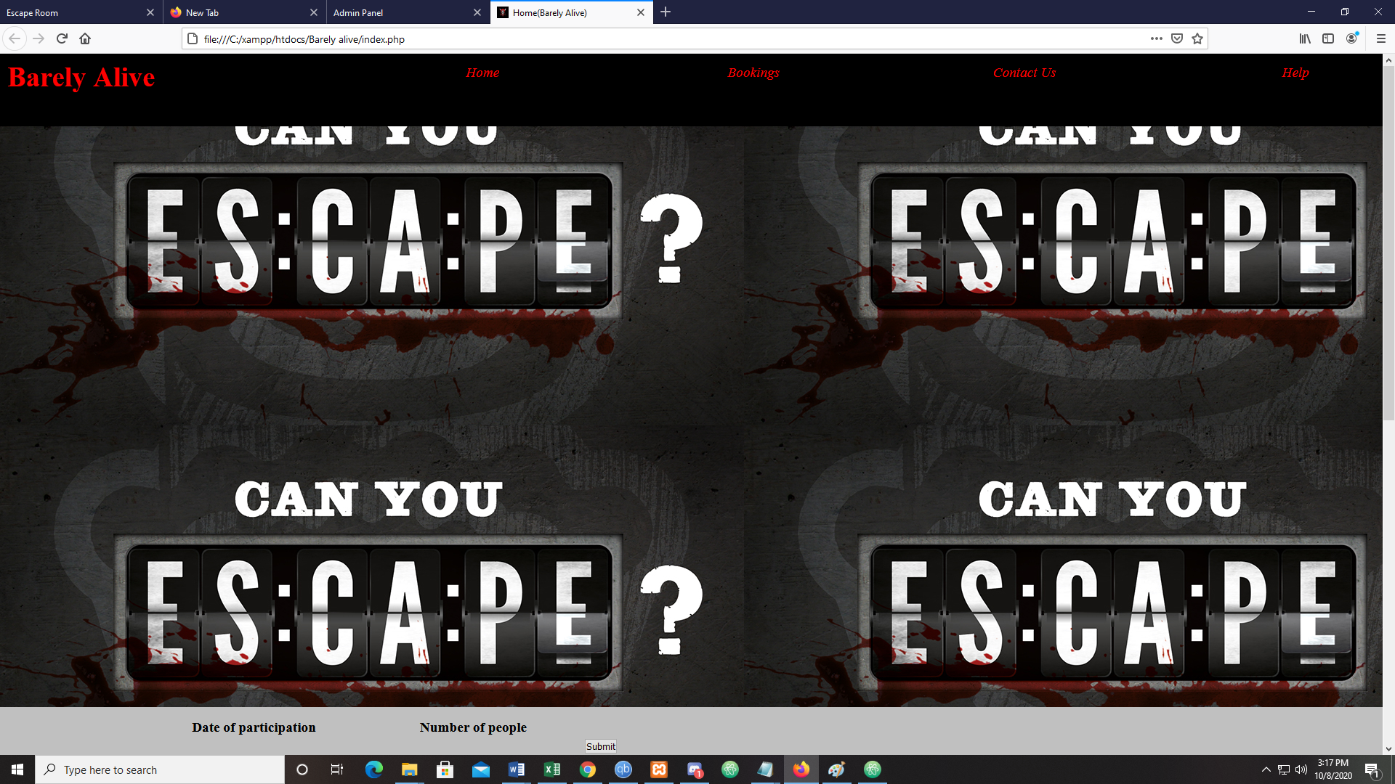

**Fig 1: this is homepage of my first attempt**

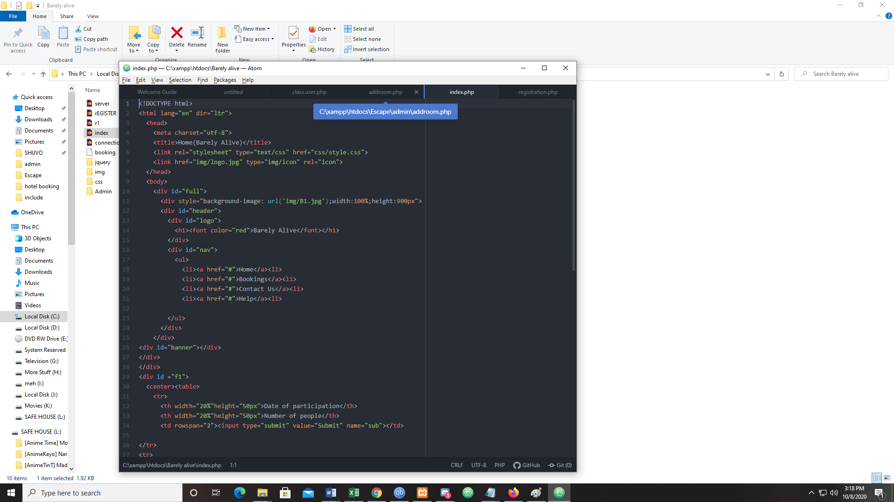

**Fig 2: code for the first page.**

Since,it didn’t workout I attempted from scratch again,and started with the new project ,where I handled the front end and some bits of the back end .The front end was ready but the backend was full of mistakes.

**THE FINAL PROJECT:**

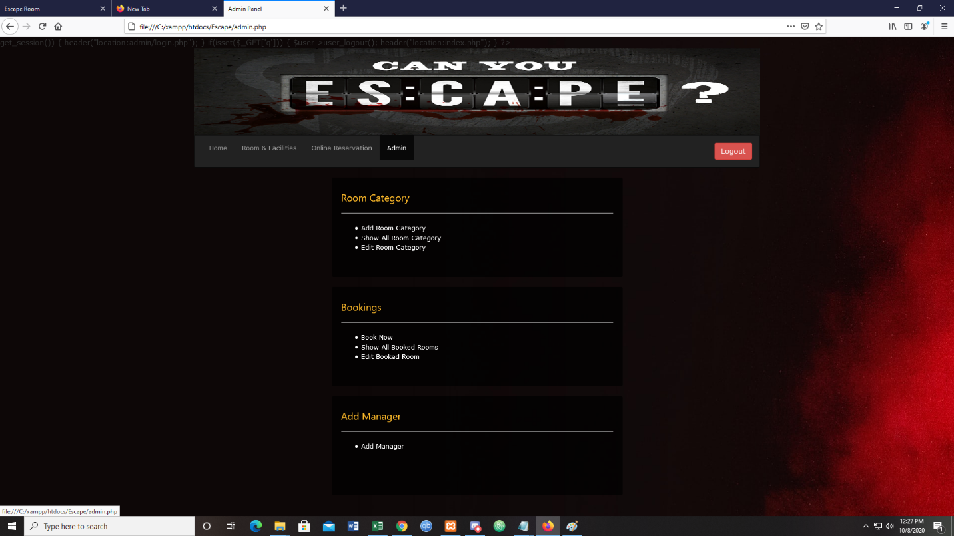

**FIG 3: Admin panel**

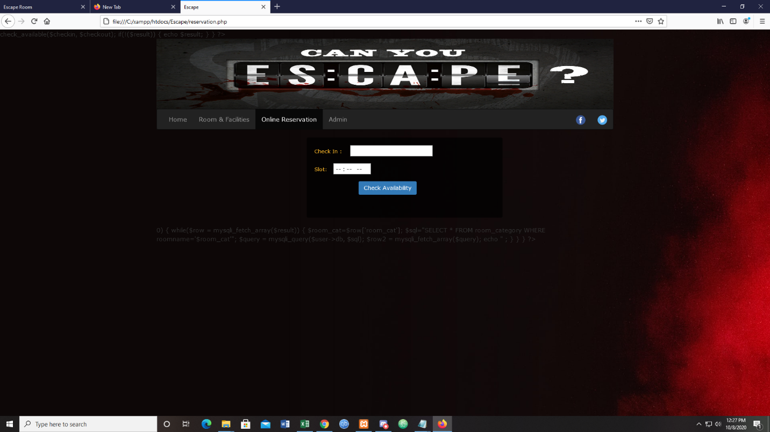

**Fig 4: Chech in page**

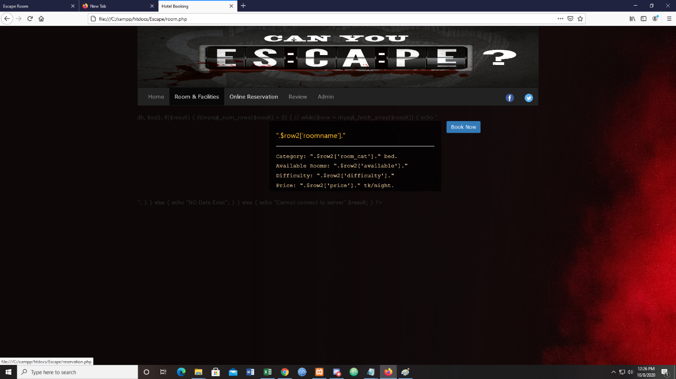

**Fig 5:Room categories.**

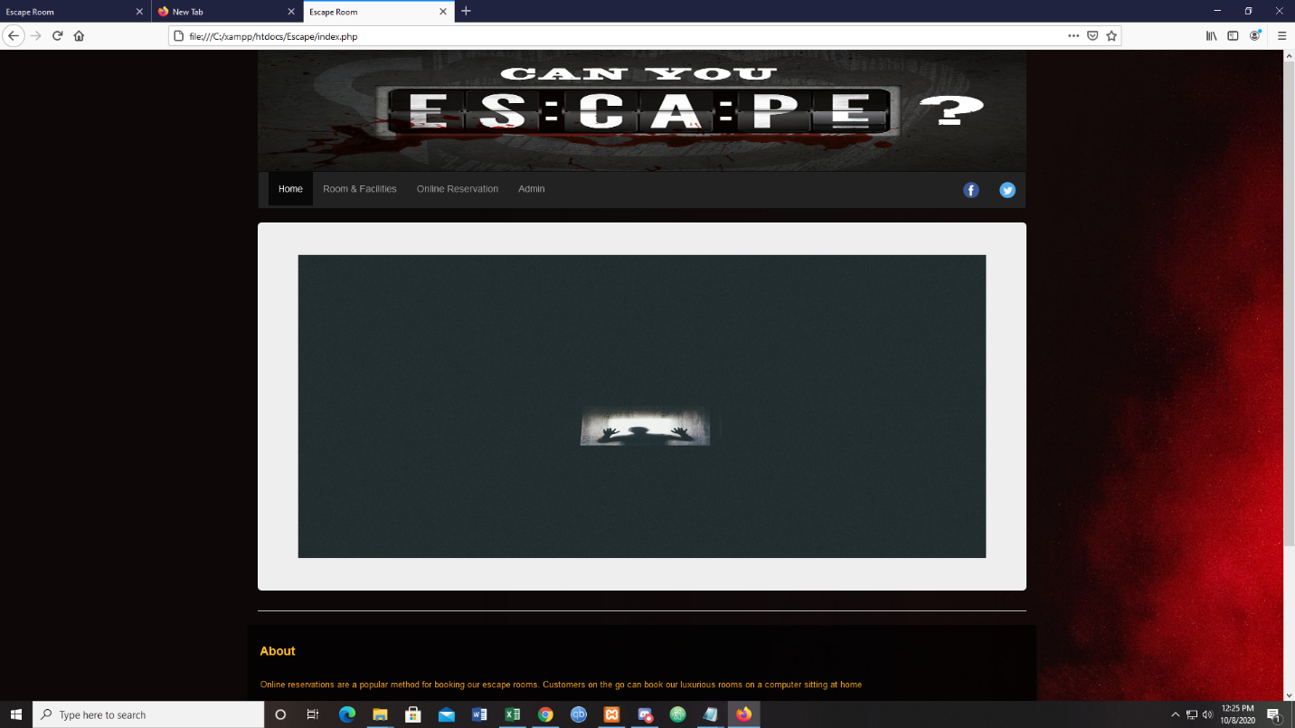

**Fig 6:Home page**

I will push the code files in github.